Langchain Vs Langgraph
07.07.2025

LangGraph
LangGraph is an orchestration framework that enables you to build stateful , multi-step , and event-driven workflows using LLMs. its ideal for designing both single - agent and multi-agent agentic AI applications .
It's a flowchart engine for LLMs - we define the steps (nodes) , how they’re connected (edges) , and the logic that governs the transitions . Langgraph takes care of state management , conditional branching , looping , pausing / resuming and fault recovery - features essential for building production-grade AI systems.

When do we use what ?
Langchain is for building simple , linear workflows - like a prompt chain , summarizer or a basic retrieval system.
Use LangGraph when your use case involves complex , non linear workflows that need :
Conditional paths , loops , Human-in-the-loop steps , Multi-agent coordination , Asynchronous or event-driven execution.

Should we still use Langchain ?
LangGraph is built on top of LangChain - it doesn’t replace it.
You’ll still use Langchain components like : LLMs , Prompt Template , Retriever , Document Loaders , Tools etc.

Challenges while using Langchain in AI agents formation :
LangGraph handles workflow orchestration while Langchain provides the building blocks for each step in that workflow.
Langchain is only for simple conversational workflows like Chatbots , Text Summarizers , Multistep workflows , RAG applications and basic level agents.

Let's take an Automated Hiring workflow :
Workflow is a predefined sequence of steps or logic to complete a task created by a developer.
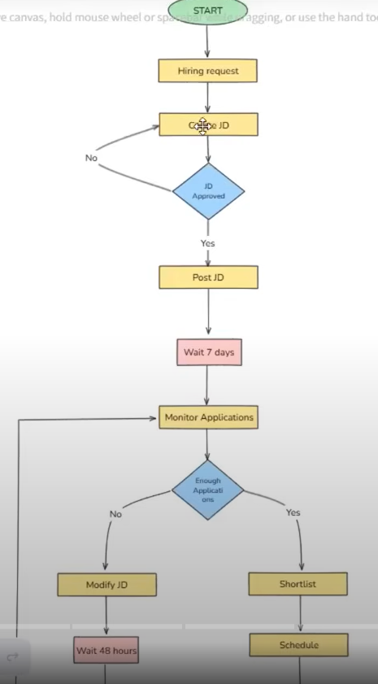
An agent is an autonomous entity that makes decisions and uses tools dynamically to reach a goal.

#Challenge 1 : Control Flow Complexity
Conditional branch , Loops , Jumps (wait for 48 hrs then again jump to previous step).
Langchain has so much glue code(python codes) for such loops and if-else.
LangGraph offers built-in functions to add nodes without glue code.

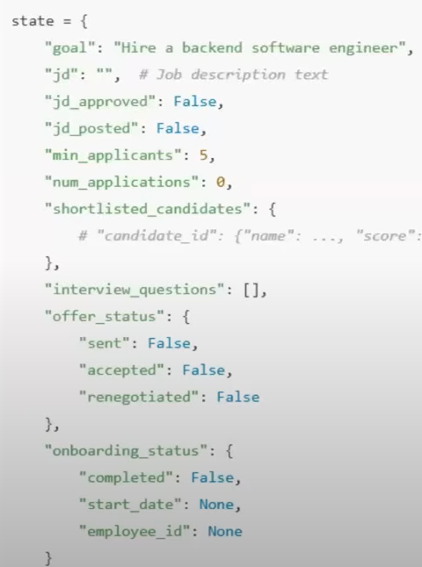
#Challenge 2 : Handling State
Langchain uses memory for conversational tasks.

For agentic AI , we need to find out which task is important . We have all the important tasks written in the dictionary as keys and their value as the points given to them . This state object is (Pydantic / Typedict) mutable i.e. any node can edit it after its task completions for helping in further tasks. The State is accessible to all nodes because they all need to know at times how much task is completed , and what is needed to go at execution.

#Challenge 3 : Event Driven Execution
Langchain can handle sequential chains only .

LangGraph can even handle event-driven i.e. when one component is complete and you need to wait for 7 days . When triggered it starts resuming but that option is not available in Langchain.

#Challenge 4 : Fault Tolerance
In Langchain , If a fault occur the chain break and executes from beginning again .
LangGraph offers retry and recovery strategies , i.e. for a big fault it pause at specific node and resume again from that node forward.

#Challenge 5 : Human in the Loop
We need to wait for human approval to proceed .
Langchain can handle it for quick approval but doesn’t offer this for delay responses.
Langgraph has alternative for it as it stops the process at that node and starts by next node when get approval. Since it’s a stateful it checks for checkpointers and proceed.

#Challenge 6 : Nested Workflows
Its a feature where one node is replaced by a subgraph i.e. a task is also divided into different tasks (multi agent).

#Challenge 7 : Observability
Langchain uses langsmith to monitor llm applications but that has so much glue code that cannot be monitored. This is partial observability.
While LangGraph uses langsmith when it can monitor the whole timeline . This is full observability.

